**WISH BONE CARD SORT STUDY ON IMPROVING THE WEBSITE**

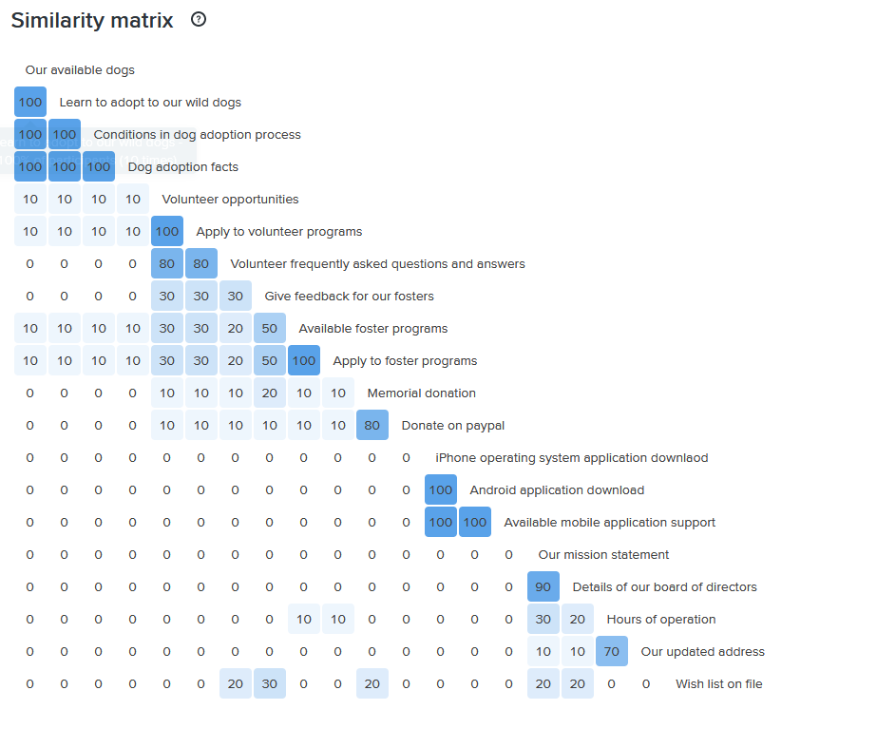

Figure 1. Similarity Matrix

**Analysis Discussion:**

Similarity matrix in Figure 1 above is shows the piece of content that are associated and how they are categorized by ten participants of the study. These associations and categorizations are briefly discussed, followed by a summary result in Table 1, detailed dendrograms result, and recommendations on how to improve the website.

Things that have to do with dog adoption flow seamlessly into the same category as well as those that have to do with volunteer, foster programs, apply to our foster programs, and downloads. Wish list on file, operations, foster, and donations also closely align with participants placing them into the same categories.

Two notable outliers are the “iPhone operation application download” and “Our mission statement” cards which appear not closely related to many other topics. There seems to be a theme showing fostering related topics such as “Give feedback for our fosters”, “Available foster programs”, “Apply to foster programs”, somewhat associated with “Wish list on file”, and each of these has a minimal association with donation related topics such as “Donate on paypal”, “memorial donation”. Most likely, the connection is that people would like to give their feedback, best wishes and donate to aid in fostering effort and programs enhancement.

Table 1. Content Association.

|  |  |  |  |  |  |  |  |
| --- | --- | --- | --- | --- | --- | --- | --- |
| Our available  dogs | Volunteer opportunities | Available foster programs | Memorial donation | Details of our board of directors | Our mission statement | Android Application download | iPhone operating system application download |
| Learn to adopt  to our wild dogs | Apply  to volunteer programs | Apply to foster programs | Donate on paypal | Hours of operation |  | Available mobile application support |  |
| Conditions in  dog adoption process | Volunteer frequently asked questions and answers | Give feedback for our fosters |  | Our updated address |  | Android Application download |  |
| Dog adoption  facts |  | Wish list on file |  |  |  |  |  |

On the topic of grouping, we want to look at how people labeled these categories.

We can see below that the topic regarding dog adoption flow nicely into appropriately named categories



The topics regarding volunteering also flow nicely into appropriately named categories.



The topic regarding fostering flow nicely into appropriately named categories.



Donations, Volunteering, and fostering are closely aligned according to the survey as seen below. There is a considerably moderate association amongst them evident by the association matrix and the dendrogram below.

Also, as seen from below, general topics mission, and directors are associated with wishes and fall nicely into appropriately named categories.



Lastly, the topic regarding downloads flows nicely into appropriately named categories.



**Recommendation:**

With all data available to me, I would suggest multiple of things. I would create a new section called Foster and move Wish List to Foster since it is associated with the topics related to Foster.

I would keep donation and volunteering in their respective categories even though they seem to have minimal similarities. This will help to avoid confusion. Also, Volunteering and Fostering have minimal similarities according to the study. In order to make it much easier to search for the pieces of content in those categories, I would separate volunteering and fostering.

In addition, I would create another section called Contact US and have Hours of operation, Our address, and Email sent to that section. I will leave Our mission statement and Details of board of directors in the About US section.

Even though iPhone operating system application download is not closely related with the pieces of content in Mobil Up, I would leave it in the Mobil Up section to avoid ambiguity. Below is how I will present the categories:

|  |  |  |  |  |  |  |
| --- | --- | --- | --- | --- | --- | --- |
| ADOPT | VOLUNTEER | FOSTER | Donate | Contact US | ABOUT US | MOBILE |
| Our available  dogs | Volunteer opportunities | Available foster programs | Memorial donation | Hours of operation | Our mission statement | Android Application download |
| Learn to adopt  to our wild dogs | Apply  to volunteer programs | Apply to foster programs | Donate on PayPal | Our updated address | Details of our board of directors | Available mobile application support |
| Conditions in  dog adoption process | Volunteer frequently asked questions and answers | Give feedback for our fosters |  | Email |  | Android Application download |
| Dog adoption  facts |  | Wish list on file |  |  |  | iPhone operating system application download |